1. Start SQL Server Studio :

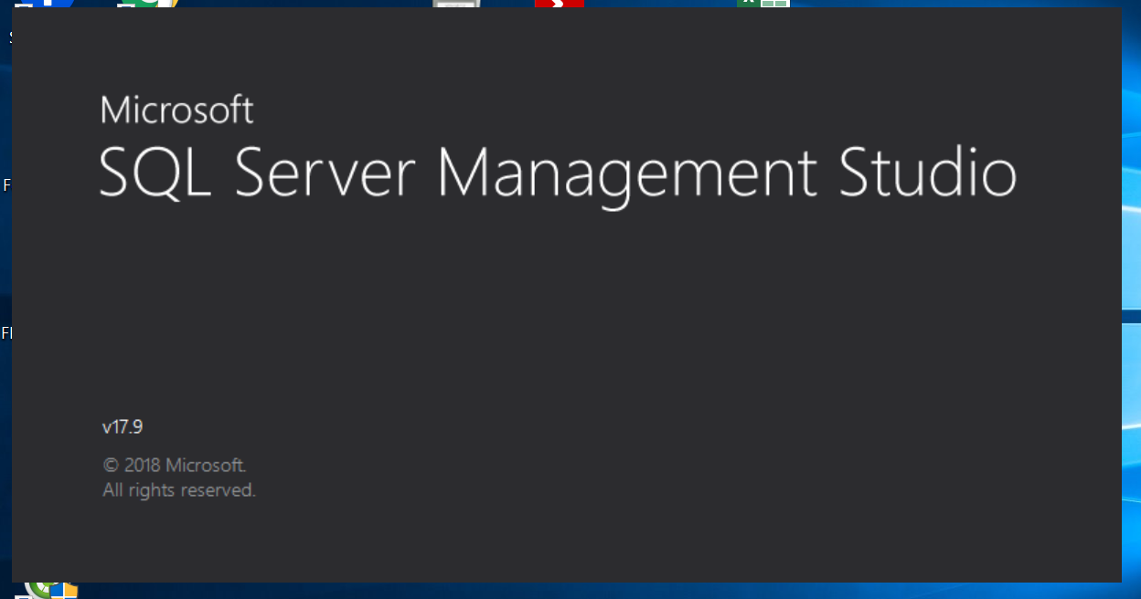

1. Connect to PRODUCTION environment :

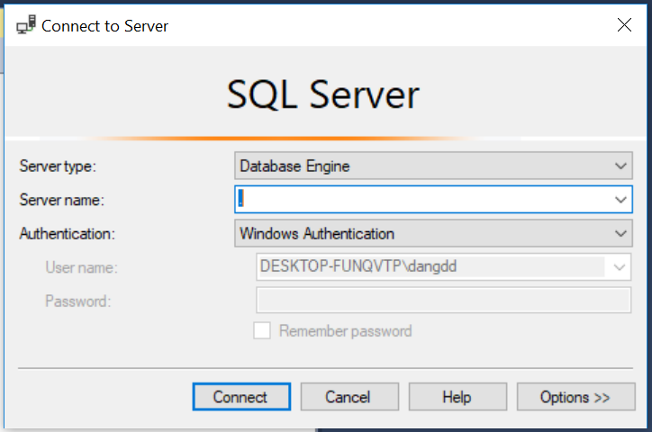

1. Open the script file to run :

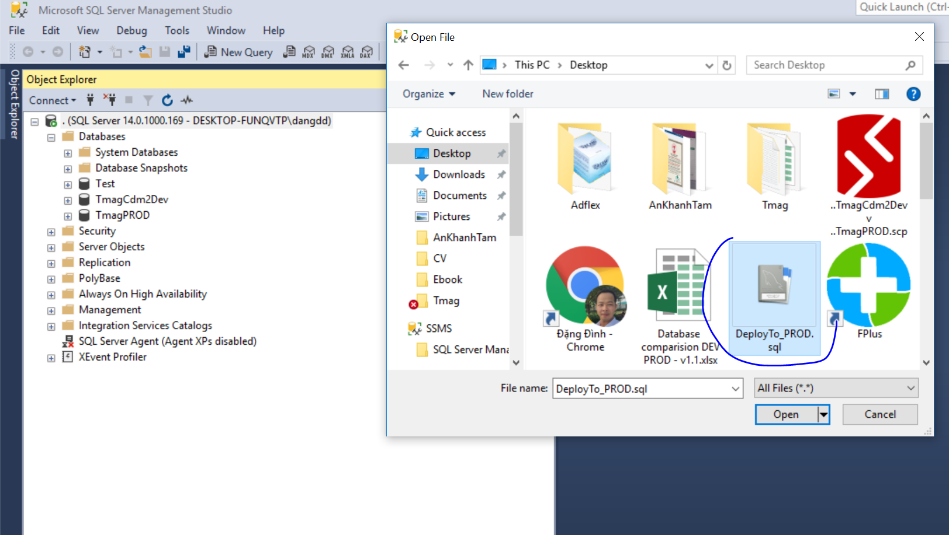

1. Select the database to run and hit the **execute** button :

